Approach
Architecture
Input = (1*28*28) (Pytorch Convention)

CNN_Light
- Conv (1 → 16, stride=2) → (16 × 14 × 14) + BN + ReLU
- Conv (16 → 32, stride=2) → (32 × 7 × 7) + BN + ReLU
- Flatten (1568)
- Linear (1568 → 128) ← bottleneck
- Linear (128 → 1568)
- Reshape (32 × 7 × 7)
- ConvTranspose (32 → 16, stride=2) → (16 × 14 × 14) + BN + ReLU
- ConvTranspose (16 → 1, stride=2) → (1 × 28 × 28) + Sigmoid

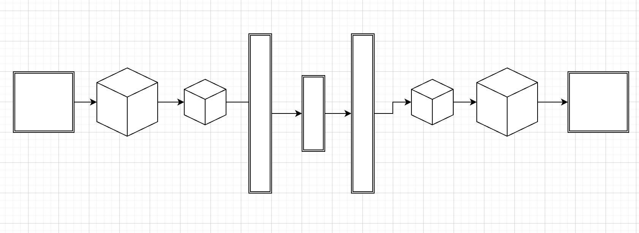
CNN_Deep

For ANN, first we flattened the image(unrolled it out into a single vector of 784 (i.e 28*28) values)

ANN_Shallow (bottleneck = 64)
- FC (784 → 512) + BN + ReLU (FC = Fully connected layer(i.e Linear)
- FC (512 → 256) + BN + ReLU
- FC (256 → 64) ← bottleneck
- FC (64 → 256) + BN + ReLU
- FC (256 → 512) + BN + ReLU
- FC (512 → 784) + Sigmoid
- Reshape (1 × 28 × 28)

ANN_Deep

Hyperparams

Batch Size = 128
No. of epochs ran = 30
Learning rate = 1e-3
Validation Fracn = 0.1 (due to the larger dataset)

TRAINING OUTPUT

Loop start

━━━━━━━━━━━━━━━━━━━━━━━━━━━━━━━━━━━━━━━━━━━━━━━━━━━━━━━
ANN_Shallow | params=1,103,184 | bottleneck=64
━━━━━━━━━━━━━━━━━━━━━━━━━━━━━━━━━━━━━━━━━━━━━━━━━━━━━━━
Epoch Train MSE Val MSE
1 0.018502 0.009535
5 0.006263 0.005784
10 0.004949 0.004719
15 0.004263 0.004042
20 0.003846 0.003644
25 0.003607 0.003463
30 0.003511 0.003436
Best val MSE : 0.003428
Loop start

━━━━━━━━━━━━━━━━━━━━━━━━━━━━━━━━━━━━━━━━━ ANN_Deep | params=1,161,680 | bottleneck=64
━━━━━━━━━━━━━━━━━━━━━━━━━━━━━━━━━━━━━━━━━━
Epoch Train MSE Val MSE
1 0.030913 0.020321
5 0.014283 0.013008
10 0.011142 0.010210
15 0.009461 0.008761
20 0.008484 0.008005
25 0.007934 0.007563
30 0.007758 0.007438
Best val MSE : 0.007433

Loop start

━━━━━━━━━━━━━━━━━━━━━━━━━━━━━━━━━━━━━━━━━━
CNN_Light | params=858,465 | bottleneck=128
━━━━━━━━━━━━━━━━━━━━━━━━━━━━━━━━━━━━━━━━━━
Epoch Train MSE Val MSE
1 0.011278 0.002229
5 0.001110 0.001135
10 0.000885 0.000923
15 0.000776 0.000808
20 0.000704 0.000765
25 0.000659 0.000703
30 0.000640 0.000689
Best val MSE : 0.000689
Loop start

━━━━━━━━━━━━━━━━━━━━━━━━━━━━━━━━━━━━━━━━━━
CNN_Deep | params=1,919,457 | bottleneck=128
━━━━━━━━━━━━━━━━━━━━━━━━━━━━━━━━━━━━━━━━━━
Epoch Train MSE Val MSE
1 0.002867 0.000489
5 0.000203 0.000192
10 0.000092 0.000079
15 0.000050 0.000044
20 0.000033 0.000031
25 0.000026 0.000025
30 0.000023 0.000023
Best val MSE : 0.000023

OBSERVATIONS FROM THE TRAINING

As seen from the observations,
CNNs perform way better than ANNs for image input as CNN have convolutional operations in them so they can understand spatial structure lot better than ANN which just unroll the entire image in a single vector

Skip connections drastically improved performance in CNN Deep form 0,000554 to 0.000023

I had initially added Dropout in ANN_Deep thinking it would help prevent overfitting, but since it’s MSE was 0.016 I realized it was underfitting and hence removed Dropout and added BatchNorm at every layer to help with vanishing gradients, which improved MSE from 0.016 to approx 0.007

Also,
I observed that changing the bottleneck creates tradeoff between MSE and compression

I first got 0.0007 on CNN Light with bottleneck 128, however when I tried to improve the compression by changing bottleneck to 64, the MSE increased to 0.001.
But there wasn’t that much change for CNN Deep, so that means I was underutilizing the CNN_Deep model and it can compress further

But I didn’t understand how can I find the optimal solution yet

RESULTS

IMPROVEMENTS
Wil try different scheduler(as CNN Deep is plateued)
Improve ANN Deep or Shallow arch, as both have a diff of v few params btw them

CONCLUSION

DOUBTS

Why does the latent space not show clear class separation, and how can it be improved if needed?

How does interpolation work for skip connections neural network

